海盗船 --- 灯光声音

Pirate Ship－Lighting & Sound

如果你不局限于满足小车行动上的功能的话，还可以添加装饰功能，灯光和声音模块。让小车形象显得更为生动活泼。LED模块非常适合运用于小车，我们分别装在小车的四个角上，代表左右的转向灯，并且可以结合蜂鸣器。

In the last tutorial, we showed you how to make your Pirate Ship move. Today we are going you show you how to build LED module and buzzer on your robot. Once assembled, your robot would come to life, sparkling and buzzing.

**硬件材料：**

**Hardware**

* 数字食人鱼白色LED发光模块 × 4

Digital piranha LED-R × 4

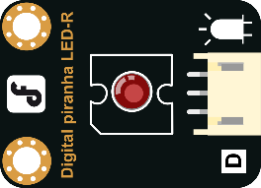

* 数字蜂鸣器模块 × 1

Digital Buzzer Module × 1

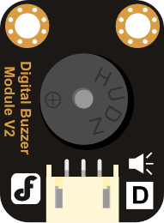

* M3*6尼龙柱、尼龙扎带 × 若干

Several M3*6 Nylon Column & Nylon cable ties

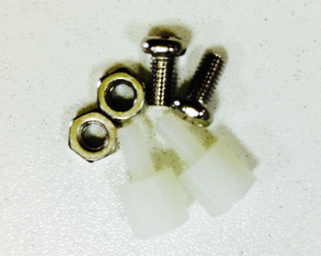 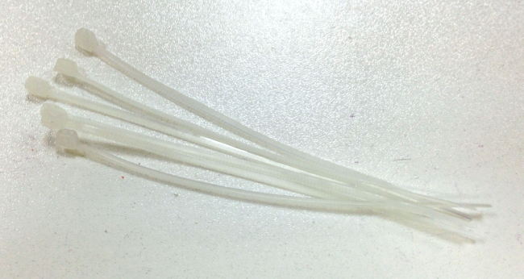

**组装步骤**

**Assembly Instructions**

准备完以上这些材料，就开始组装了，组装不难，更着操作就行。

After preparing the hardware pieces, it’s time to get started — just follow the below instructions step-by-step.

**STEP 1: 安装蜂鸣器模块**

**STEP1: Assemble the Digital Buzzer Module**

先将尼龙柱固定到蜂鸣器上，如下图所示。再用螺母将其固定到小车的上层顶板的正面。

Please put the nylon columns on the buzzer just as it is shown in the photo below. Then fix them on the façade of the top plate with nuts

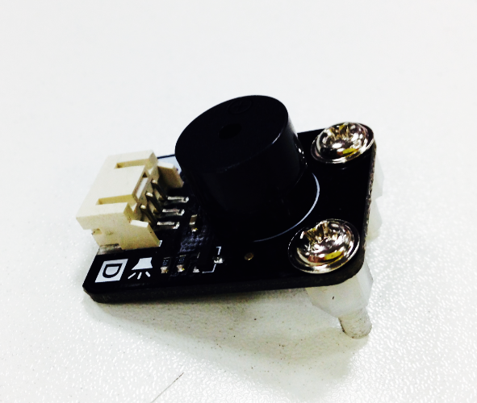 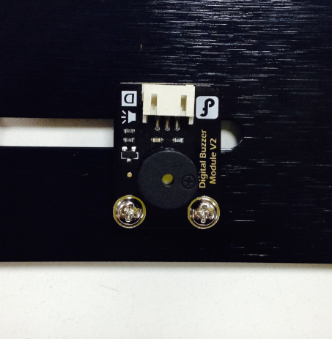

**STEP 2: 安装LED模块**

**STEP: Assemble the LED module**

安装完蜂鸣器之后，需要安装4个LED。还是先将尼龙柱固定到每个LED灯上。并用螺丝固定，如下图所示。

There are four LED lights to be installed. Please fix nylon columns on the LED lights with nuts. The finished ones are shown as follows.

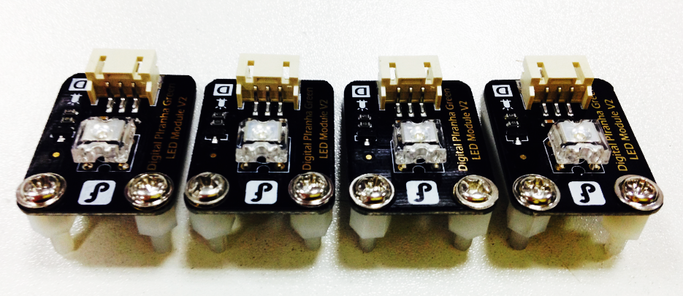

完成后，分别将4个LED固定到小车的顶板四个角。注意：是安装上层板的背面，如果你想让LED更明显一点的话，当然你也可以安装在正面。

Then fix the four LED lights on the back to the top plate of the car. Of course, you can also fix them on the façade of the plate if you want.

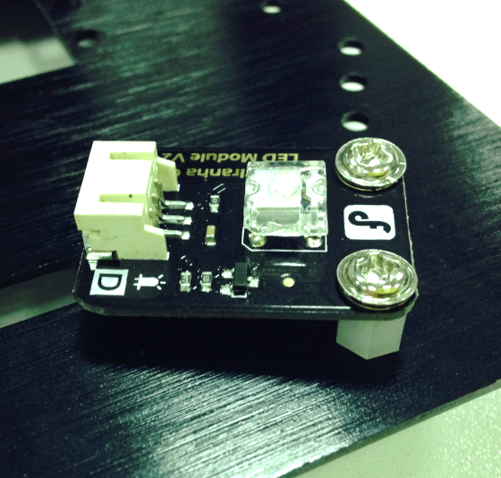

下面两张图分别是上层板的正面和背面。蜂鸣器在正面，LED则在背面。

The two photos below show the façade and back of the top plate. The buzzer is fixed on the façade while the LED lights are on the back.

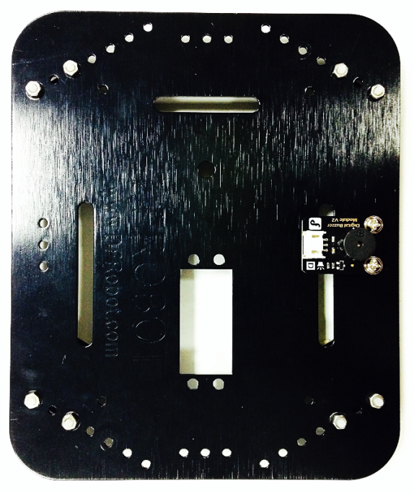 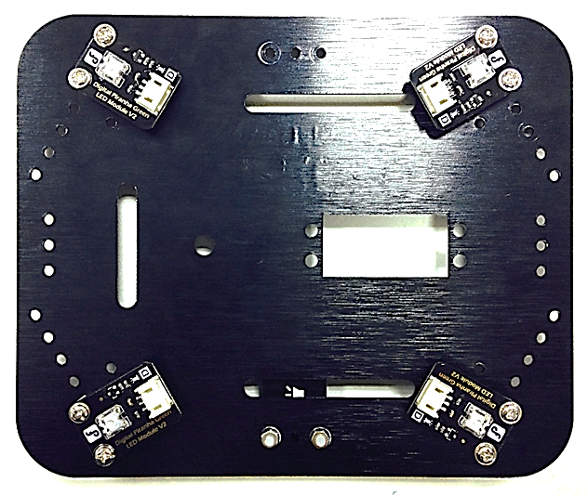

**STEP 3: 制作LED连接线**

**STEP 3: Make Cables for the LED Lights**

虽然这里使用到了4个LED，但同侧灯我们是做相同的控制，所以，为了减少IO口的使用，最简单的方法就是将信号线一分为二。以下步骤就是教你如何制作这样一根线。

There is one switch for lights on the same side. To reduce the use of IO, we only use two signal cables. Now let’s start making the cables.

先取出两根数字口信号线，并用剪刀将其一剪为二，如下图所示。

Please take out two digital signal cables and cut them into half as it is shown in the photo below.

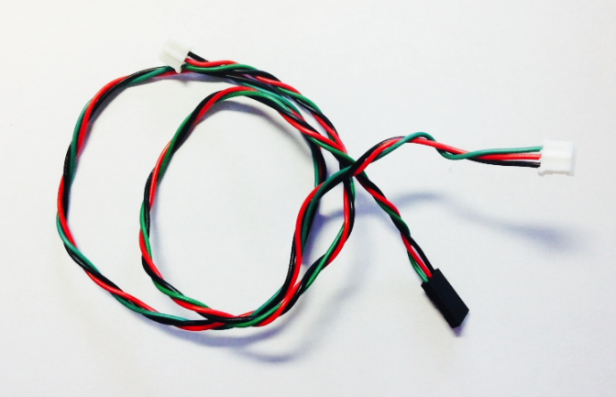

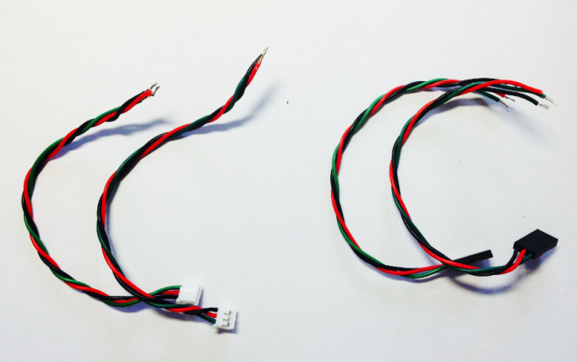

取出其中两根带PH2.0母头（白色接头）的杜邦线和一根带3Pin公头（黑色接头）的

杜邦线，将杜邦线头部用剥线钳剥去，露出线内部的铜线部分，并且焊上少量锡，便于焊接。

Take out two Dupont lines with PH2.0 mini USB and one with 3Pin Macro USB. Strip the insulation at one end of the Dupont lines and weld the exposed wires with some tin.

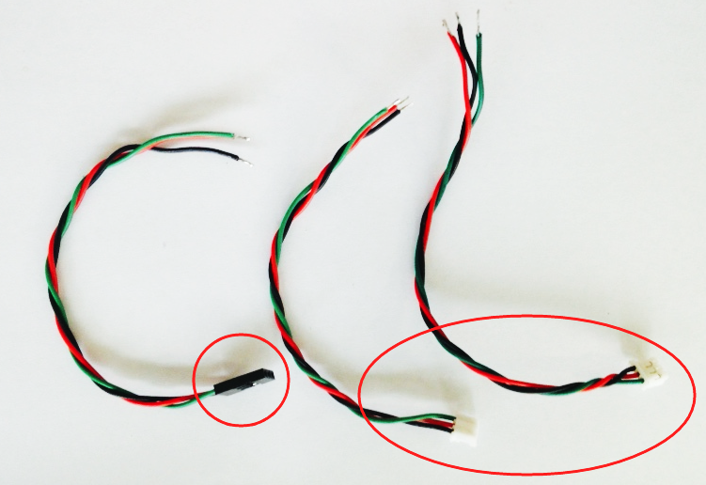

分别将三股杜邦线中的红色（VCC）焊接在一起，如下图所示。

Now there are three bundles of Dupont lines. Wield the red one (VCC) in each bundle together.

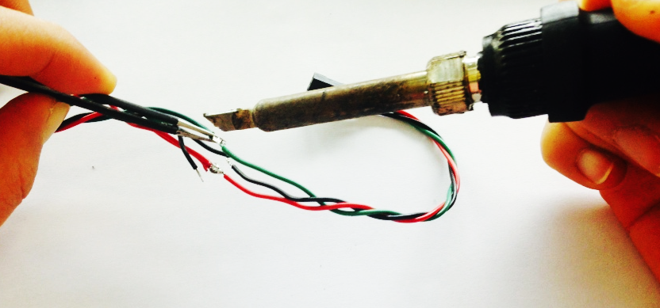

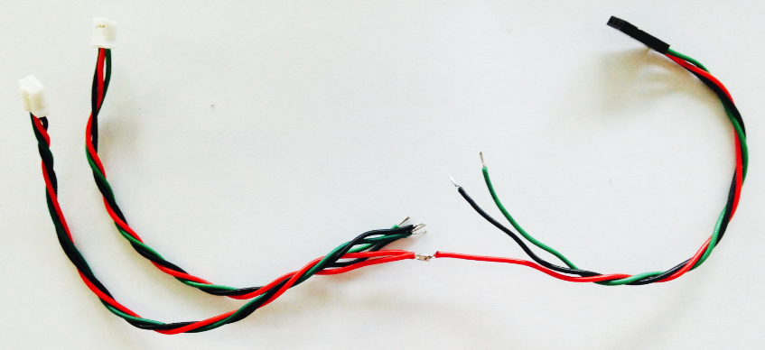

以相同方法焊接黑线和绿线，完成后的样子是这样的！

Now weld the black lines and green lines in the same way!

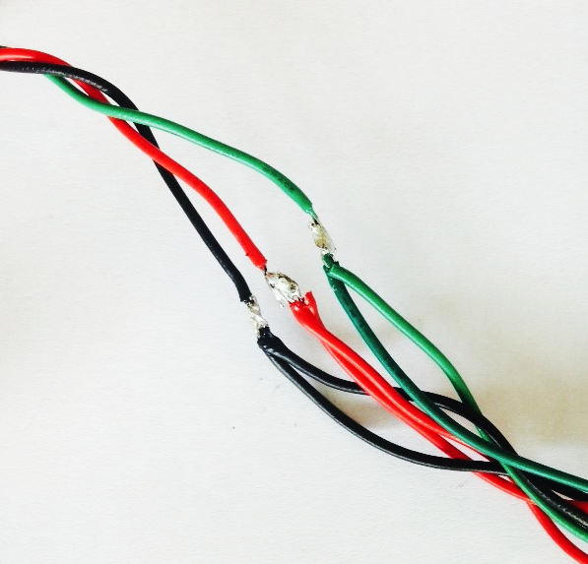 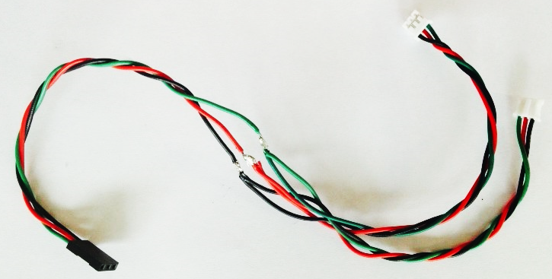

焊接完成后，记得用绝缘胶布将焊点包裹起来，以防在使用的时候出现短路。

Once welded, please remember to wrap the welding points with insulated tape in case of a cutting-out.

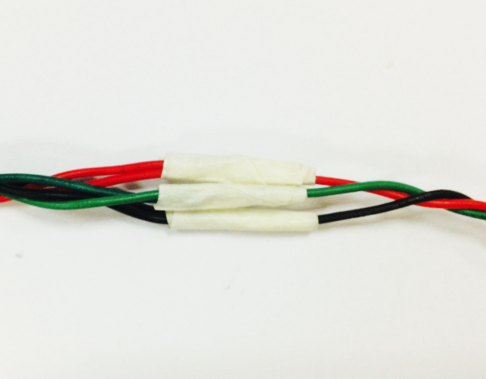 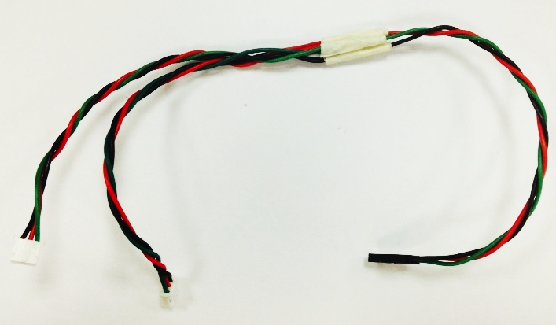

因为我们需要用到两根这样的线，所以以相同的方法再做一根。

Now make one more cable for the LED lights as we need two.

**STEP 4: 接线**

**STEP: Connect the Cables**

如果线做好的话，就可以直接连接到4个LED上了，需要提醒的一点是，同侧的2个LED公用一个数字信号口。

Connect the cables to the four LED lights. Please notice that the two LED lights on the same side share the same digital signal port.

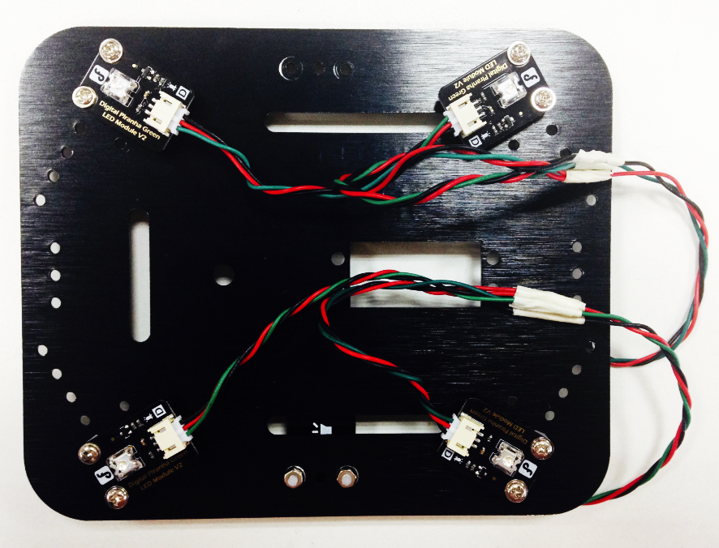

**STEP 5: 完整效果图**

**STEP 5: What It Looks Like When Finished**

建议先不要将小车上层的顶板固定上去，因为我们下一步就需要硬件电路连接了。

We suggest that you don’t add the plate now as the hardware circuit shall be connected next.

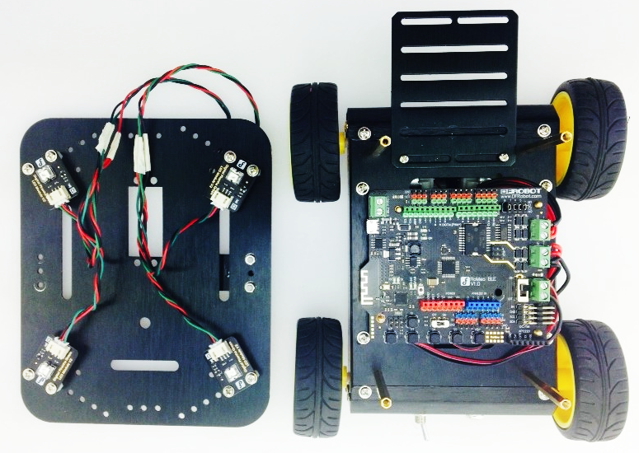

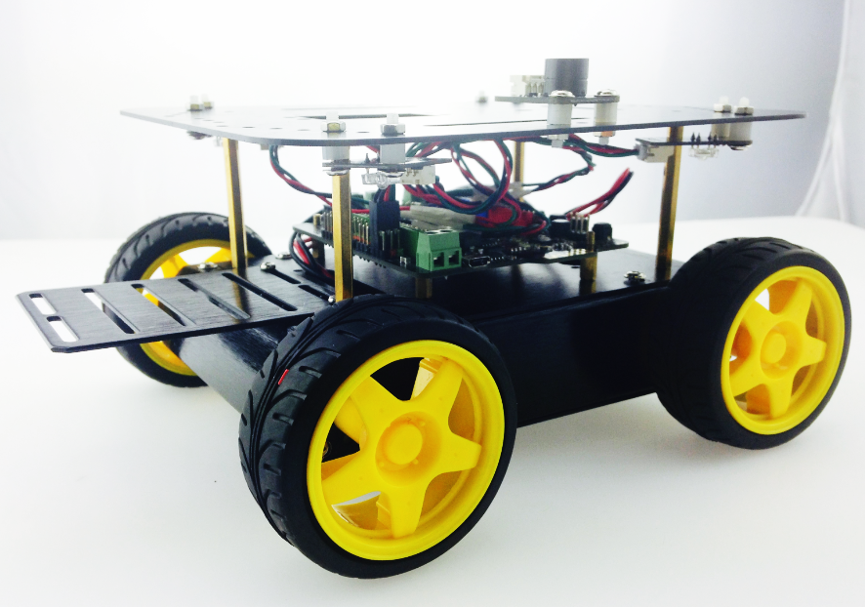

至此就全部安装完了，下面就开始硬件连接了。

Now let’s connect the LED module to the car.

**硬件连接**

**Hardware Connection**

可以从连线图看出，同侧的两个LED是共用一个信号口的，左右分别用B,A来代替。A侧的LED连接的数字信号2， B侧的LED连接的是数字信号11。蜂鸣器则接的是数字信号3。

As it is shown in the map below, two LED lights on the same side share the same signal port. A represents the right side with the digital signal being 2 while B represents the right side with the digital signal being 11. Digital signal for the buzzer is 3.

说明：红色为VCC，黑色为GND，绿色为信号线。

Note: The red line is VCC; black line is GND; green line is signal cable.

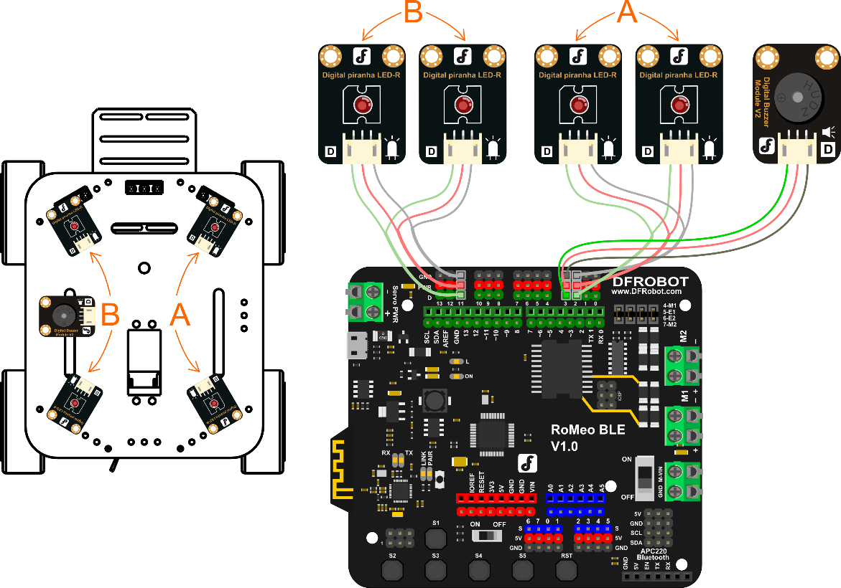

安装完成后，就可以将上层板固定上去了。准备下载代码…

Once assembled, we can add the upper plate. Ready for downloading the code.

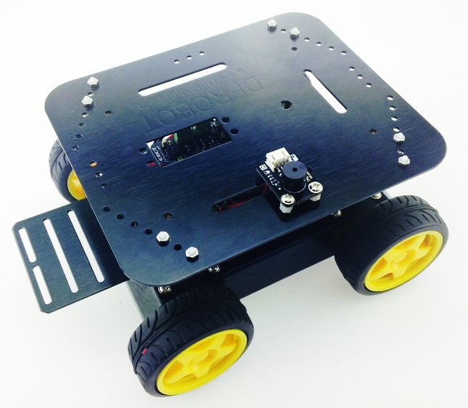

**输入代码**

**Type in the Code**

插上USB线，下载代码。你可在软件包中找到Light_Sound.ino的代码，直接点击下载。当然，不要忘记选择Board和Serial Port

The Light_Sound.ino code can be found in the software package. Click it and downloadd. Of course, don’t forget Board & Serial Port.

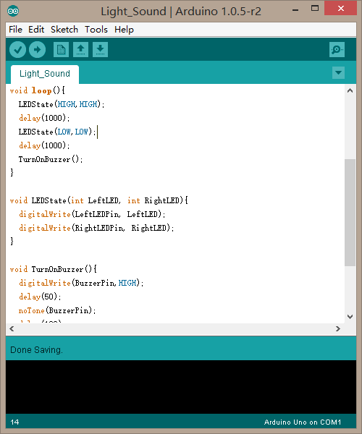

下载完成后，你看到的效果应该是，4个LED同亮同灭，并伴随蜂鸣器的滴滴声。代码不难，简单来看下。

Once downloaded, you shall be able to turn on or turn off the four LED lights at the same time and hear the buzzing sound of the buzzer. Now let’s take a look of the coding.

**代码回顾**

**Review of the Code**

代码开始部分，还是一些变量的声明：

At the beginning of the code is some information about the variables.

int LeftLEDPin = 11;

int RightLEDPin = 2;

int BuzzerPin = 3;

表示左边LED接到数字引脚11，右边LED接到数字引脚2，蜂鸣器则接到数字引脚3。

int LeftLEDPin = 11; means LED lights on the left are connected to No.11 dgital pin; int RightLEDPin = 2; means LED lights on the right are connected to No.3 dgital pin; int BuzzerPin = 3;

means the buzzer is connected to No.3 dgital pin.

pinMode(LeftLEDPin,OUTPUT);

pinMode(RightLEDPin,OUTPUT);

pinMode(BuzzerPin, OUTPUT);

同样需要设置下数字引脚的模式，LED和蜂鸣器都为输出模式（OUTPUT）。

Also digital pins, LED lights and buzzer shall all be set be to in the OUTPUT mode.

再看下loop()函数，里面只有两个函数LEDState(),TurnOnBuzzer()。

Let’s look at the function of loop(), which included two functions: LEDState() & TurnOnBuzzer()

LEDState(LeftLED,RightLED)

LEDState()是用来设置左右LED的状态的。就拿程序中的例子来说：

LEDState() is used to set the state of LEDs on the same horizontal line. Take one case in the program for an example

LEDState(HIGH,HIGH);

这句话的意思是，左右的LED都设置为HIGH，也就是同时打开左右的LED。

It means that LED light on the same horizontal line can be turned on or turned off at the same time

LEDState(LOW,LOW);

相反的，这句话意思是，同时关闭左右两边的LED。

Vice versa.

如果说，碰到左转，只需打开左边的LED，关闭右边LED的话，就可以这么写：

But if you only want to turn on the LED lights on the left and keep the ones on the right off, the code shall be written as follows.

LEDState(HIGH,LOW);

蜂鸣器那个函数很简单，只是打开蜂鸣器。可以看下TurnOnBuzzer()函数。

Function for the buzzer is quite simple. Please check the fuction of TurnOnBuzzer() out.

其实就是通过一个digitalWrite()函数来给蜂鸣器引脚至高，一旦至高后，蜂鸣器就能发出声音了，并通过调节中间的延时时间，来控制播放声音的时间，也就能模拟出一个警报音了。

In fact, the function of digitalWrite() is used to lift the pin for the buzzer to make it start buzzing. Meanwhile, we can adjust the delay time to control the duration of the buzzing sound.

**大改造**

**Overhaul**

如何控制LED和蜂鸣器的方法已经学过了，那就试试自己做一个音效声出来，可结合各种各样的形式。在之后综合部分就能使用你自己特制的音效了。

Do you know how to control the LED lights and buzzer now? Start making your robot buzz! MAKE IT SPECIAL.